Title: Use Case Overview for System C.H.A.T  
Sub-Title: “Use Case Overview PA1435 Object Oriented Design”  
Date: 2018-04-04

|  |  |  |  |
| --- | --- | --- | --- |
| **Author Name** | **Social Security Number** | **Thinking (%)** | **Writing (%)** |
| Alexander Dahlin | 9708084638 | 25% | 25% |
| Christoffer Andersson | 9702217630 | 25% | 25% |
| Herman Hansson Söderlund | 9710109472 | 25% | 25% |
| Tim Mellander | 9107191398 | 25% | 25% |

System Description

The system is a created to get an overview of different warehouses. A user could for example be a worker at the warehouse that needs to easily get an overview of the current state (were trucks are, current inventory etc.) The main goal is for workers to easily locate where certain goods are stored, and to direct a truck to either fetch or deliver it to a desired location.

Managers of the warehouse, e.g administrators, can use the system to add new warehouses. Users and administrators (administrators are users with extra privileges) also have the ability to communicate with each other by sending text messages.

Use Cases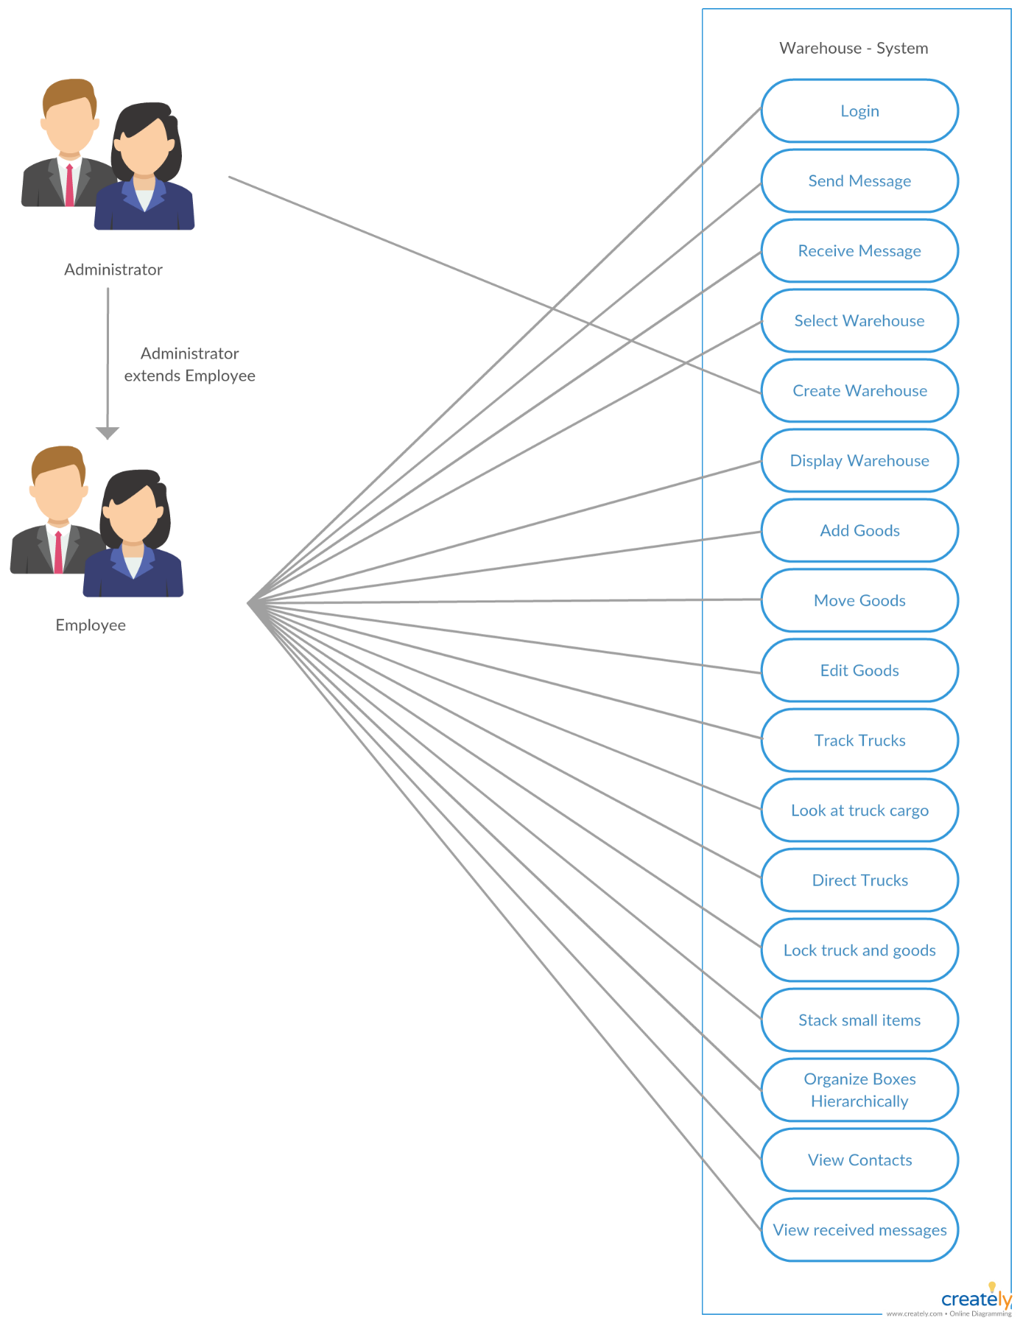 Diagram

Description of Actors

In this system we have two different actors, these are users or employees and administrators. Administrators have the same privileges as users except that they can also create new warehouses. The users are the ones using the system to manage the warehouse.

High-Level Use Cases

Name: A user can login

Actors: User, Administrator

Description: A user enters a username and password, gets logged in, and can access to the system.

Name: Send Message

Actors: User, Administrator

Description: User/Admin send private messages, by selecting another user/admin as a receiver and writing a message.

Name: Receive Message

Actors: User, Administrator

Description: User/Admin can receive and read private messages from other users/admins.

Name: Select Warehouse

Actors: User, Administrator

Description: A user/admin can select a warehouse from a list on the home screen to view and interact with.

Name: Create Warehouse

Actors: Administrator

Description: An administrator can create a warehouse through an interface only accessible by administrators.

Name: Display Warehouse

Actors: User, Administrator

Description: A user/admin can display a map of the currently selected warehouse. The map shows the warehouse’s isles, goods and trucks.

Name: Add Goods

Actors: User, Administrator

Description: A user can add goods to the warehouse. This is done by opening a window and selecting goods to be added from a list.

Name: Move Goods

Actors: User, Administrator

Description: A user can select goods and move it around using cursor keys.

Name: Edit Goods

Actors: User, Administrator

Description: A user can select goods and edit different attributes of the goods. These attributes are price, dimensions and weight.

Name: Tracking Trucks

Actors: User, Administrator

Description: A user can locate any truck live on the warehouse-map.

Name: Look at a trucks cargo

Actors: User, Administrator

Description: A user can select a truck and see what cargo it is carrying.

Name: Direct trucks

Actors: User, Administrator

Description: A user can select a truck and direct it to a new location by clicking on a valid location on the map.

Name: Lock truck or goods

Actors: User, Administrator

Description: Each item or truck will be locked when selected by any user. This means that another user cannot interact with the entity at the same time as another.

Name: Stack small Items

Actors: User, Administrator

Description: Smaller items can be stacked in a box called collection by placing a item on another similar item. This collection can be moved around the warehouse as one item.

Name: Organize Boxes Hierarchically

Actors: User, Administrator

Description: Goods can be a subtype of another item. For example Big-Boxes is the main-type and has the four sub-types: Cold-Storage, Hot-Storage, Soft-Box, Hard-Box. This means that these boxes has the same outer dimensions so that they easily can be organized and stacked together.

Name: View contacts

Actors: User, Administrators

Description: A user can view contacts (All users in the system). A contact can be selected as a reciver of a message.

Name: View recieved messages

Actors: User, Administrators

Description: A user can view all the messages that have been recived. Select a message to get see the whole text.